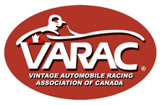VARAC 2018 Annual General Meeting

Date/Time: November 4th, 2018 / 10:00am
Location: Sheraton Parkway Toronto North Hotel & Suites, 9005 Leslie Street, Richmond Hill, Ontario, L4B 1B2.
Present: Ted Michalos [Chair], Emily Atkins, Gord Ballantine, Andrew Celovsky, Dave Good, Gavin Ivory, Chris Rupnik, Ivan Samila, Brian Thomas, Julie Wildman.
Absent: Rob McCord

- Business arising from the 2017 AGM. None.

- Review and approval of minutes of the 2017 Annual General Meeting.
M/S/C That the minutes of the 2017 Annual General Meeting be accepted and approved.

- Quorum: G Ivory reported 40 members were present in person and 11 by proxy, constituting an AGM quorum [being greater than 10% of the 181 members, as of the AGM].

- Opening remarks from Ted Michalos, President. T Michalos welcomed members, introduced the 2018 Board and thanked them for their contribution.

- Directors’ reports. The 2018 AGM Agenda and Supplementary Materials [including highlights of the 2018 Board activities, Directors’ reports, and proposed motions and discussion topics] were emailed to members on Oct 14th, and posted on the VARAC website [satisfying the required 21 day notice period], along with minutes of the 2017 AGM. At the 2018 AGM, Directors provided the following comments regarding their 2018 activities, which should be read in conjunction with their previously submitted reports:

  - Treasurer – Julie Wildman. Reported that VARAC ended 2018 in solid financial condition with a $32,559 surplus, compared to $31,385 in 2017, and referred members to her report previously distributed to members.

M/S/C That the 2018 VARAC financial statements as presented be accepted and approved.

  - Secretary – Gavin Ivory. Reported that the 2018 Board met eight times, including the AGM. A summary of 2018 Board meeting activities is appended.

  - Membership - Ivan Samila. I Samilla reported that VARAC had 181 members, of which 17 were lifetime. 120 VMC/VARAC licences and 10 novice licences had been issued. Only 61% of members had submitted completed eligibility forms, noting more compliance is required. The process for submission was reviewed, including the car update procedure. Members were reminded that no licence would be issued without a photo, and racers are not eligible for Championship points without a completed Eligibility form.

  - VGP – Ted Michalos. T Michalos reviewed the 2018 VGP, noting the overall theme of “more track time” and the feature events. There were 273 entrants, and the event returned a profit of approximately $30k. T Michalos thanked the VGP Committee. There was discussion about excessive grid sizes.

  - Conduct – Gord Ballantine. G Ballantine thanked the members of the Conduct Committee. In 2019 racers will be again be reminded of conduct reporting requirements. G Ballantine noted that the overall incident rate for 2018 was relatively low, with the exception of the VGP which was marred by excessive conduct incidents, including 28 spins, eight 3mos probations, four 13mos probations, and two suspensions. Following the VGP, D Good led a committee to find ways to reduce future VGP track incidents.

  - Rules and Regulations – Chris Rupnik. C Rupnik discussed the changes to the VH tire eligibility rules for 2019, allowing the addition of three specific tires: [1] Toyo R888R; [2] Kuhmo V700; and [3] Pirelli Trofeo R. There was discussion on the widespread use of asymmetric tread tires in US vintage clubs. In 2018, CR also reviewed VARAC rules generally in comparison with CASC rules and found no conflicts.

  - Eligibility [VH] – Dave Good: D Good reported that his efforts centered on three areas: [1] eligibility; [2] soring; and [3] mentoring. In addition, the committee struck to review 2018 VGP incidents concluded with five recommendations: [1] reduced grid sizes; [2] more VARAC website information on the CTMP race track; [3] at-track promotion of CTMP’s high speed nature; [4] improved communication with CTMP race event officials; [5] requirement for VGP racers to immediately self-report following any incident. Discussions: [1] self-reporting requirements at US clubs; [2] TM noted 2109 VGP will issue helmet stickers to enforce drivers’ meeting attendance and that Test Day will continue to be mandatory for new-to-CTMP 2019 entrants; [3] new VARAC racer mentoring; [4] clarification of requirements for VARAC/VMC licence; [5] at-track discussions with problem racers.

  - Eligibility [Classic] – Rob McCord: T Michalos summarized R McCord’s report, as previously submitted.

  - IT and Communications – Emily Atkins: E Atkins reviewed the very high level of member engagement with web-based communications, at 65% plus.

M/S/C That the actions of the 2018 Board be accepted.

- Election of directors. T Michalos reviewed the terms of current Directors.
TM and GI reviewed the positions and term expirations of the current Board. The following Directors will serve the remainder of their term as indicated:

i. Dave Good - Vice-President and Director, Eligibility Chair [Vintage/Historic] – is entering the second year of his three-year term.
ii. Rob McCord - Vice-President and Director, Eligibility [Classic] – is entering the second year of his three-year term.
iii. Gavin Ivory - Secretary is entering the second year of his three-year term.
iv. Emily Atkins - Director, IT and Communications – is entering the second year of her three-year term.
v. Andrew Celovsky - Director, At-Large is entering the second year of his two-year term.
vi. Brian Thomas - Director, Conduct Co-Chair is entering the second year of his two-year term.

The Board proposed the following Directors for re-election, with terms as indicated:

i. Ted Michalos - President served his term and is standing for a three-year term. He will continue as VGP Chair, and Race Director.
ii. Julie Wildman – Treasurer has served her term and is standing for a three-year term.
iii. Gord Ballantine - Director, Conduct Co-Chair has served his term and is standing for a three-year term.
iv. Chris Rupnik - Director, Rules has served his term and is standing for a one-year term.
v. Ivan Samila - Director, Membership has served his term and is standing for a one-year term.

T Michalos nominated the following members as additional Directors for a three-year term [2021]:

John Hawkes
Peter Viccary

There were no additional nominations from the floor, and no further discussion.

M/S/C That the proposed Board slate be approved.

- New motions.

Motion: proposed by T Michalos; Second by P Viccary
For the 2019 racing season to allow Club Fords, as defined under the Monoposto rules, to run on the vintage historic grid at CASC-OR regional races as part of VARAC’s Formula Classic division. Entrants must be VARAC members.

Discussion: [1] Amendment that entrants be VARAC members to enable enforcement of VARAC Conduct rules. [2] Possibility of splitting grids. [3] TM noting that the event organizing club controls the grids – VARAC will request that organizing Club recognize the requirement that entrants must be VARAC members. [4] Clarification of car date eligibility – will use Monoposto rules. [5] Various potential safety concerns, such as FV cars running in a “train”, and car visibility.

M/S/C That the motion be accepted.

Motion: proposed by T Michalos; Second by P Viccary
For the 2019 racing season to allow Formula Vees, as defined under the CASC-OR rules, to run on the vintage historic grid at CASC-OR regional races as part of VARAC’s Formula Classic division. Entrants must be VARAC members.

Discussion: Amendment that entrants be VARAC members to enable enforcement of VARAC Conduct rules.

M/S/C That the motion be accepted.

Motion: proposed by T Michalos; Second by B Thomas
For the 2019 racing season to require all vintage and historic cars which weigh more than 2,500lbs to run on the Classic grid at CASC-OR regional racing events. The VARAC Race Director is to be allowed the discretion to permit specific Vintage/Historic cars over 2,500lbs to run on the VH grid based on an application by the driver on a case by case basis.

Discussion: [1] Amendment that only Vintage/Historic cars over 2,500lbs may be eligible for exemption consideration. [2] TM will contact owners of VH cars over 2,500lbs that may not have safety equipment that complies with G70 rules.

M/S/C That the motion be accepted.

There were no further motions from members.

- Discussion topics.
  - J Greenwood asked about the 2018 Ted Powell grid change from VH to Sportsmen shortly before the event. TM explained that low VH entries prior to the event risked removal of the VH grid, and the decision was made to accept four cars eligible for Sportsmen. TM noted the Sportsmen grid is intended to encourage Classic cars to enter events not held at CTMP. JG also felt race entry fees were excessive, and that lower fees – especially at poorly attended events – would encourage more entrants.
  - D Good said that over the past 1-2 years he has received approximately four requests from members seeking exemption acceptance to VH for cars prepared beyond the VH rules and solicited the members’ willingness to accept such cars in order to encourage larger grids. Opinion was divided between those who wanted strict adherence to preparation rules and those willing to consider exceptions on a case-by-case basis.

- New business.
  - T Michalos discussed the new Board-approved race class time brackets [appended below], whose purpose is to apply a universal bracket labelling system across all VARAC classes. Proposed new class car decals were shown. There were discussions on lap-time differences for any specific car on the different tracks leading to possible inappropriate bracketing depending in the track, whether racers were required to display class decals [not required], and the desirability for some flexibility in bracket lap times.
  - T Michalos introduced the preliminary 2019 VARAC race schedule [appended below], noting it was similar to 2018. The 40th VARAC anniversary event is one day at Shannonville, location of VARAC’s first event. The Ted Powell event is an “invitational meet” with a cost per grid of $6,000. VARAC has discretion over entry fees, and there was discussion over lowering entry fees for this event. TM noted that Championship points for VH/FC and Classic will draw from best six of eight and best five of seven events respectively.
  - T Michalos reviewed plans for the 2019 VGP:
    - Three VH grids [40-45 entrant limit]; two Classic grids; one Toyo grid; one FC grid. All based on new time brackets.
    - The band is booked; the paddock tour is scheduled; the Saturday dinner food is improved.
    - Historic F1 may be a guest grid; Volvos will get a feature grid if the Volvo Club commits to 20 entrants.
  - Brief further discussion on a mentoring program.

- Meeting was adjourned.

---------------------------------------

Appendix:

Summary of 2018 Board meetings

Feb 7, 2018. Cash balance $123,345. 106 paid 2018 members.
Discussions on:
- Revisions to 2018 event schedule
- 2018 VGP grids and event activities
- Improved eligibility form submissions
- Future structure of Conduct Committee
- Increased VARAC exposure in Quebec

Mar 7, 2018. Cash balance $123,621. 125 paid 2018 members.
Discussions on:
- Update on 2018 VGP entrants by grid, non-race activities, and car eligibility requests
- Update on Sumac membership database
- Possible CASC/VARAC mentoring program
- Alignment of VARAC conduct rules with VMC

Apr 4, 2018. Cash balance $125,499. 155 paid 2018 members.
Discussions on:
- 2018 VGP update, including sponsors and mentor program
- Conduct Committee appeals process
- Update on increased Quebec exposure
- CASC car preparation rule changes
- Clarification of VARAC/VMC vs CASC licences

May 2, 2018. Cash balance $113,459. 167 paid 2018 members.
Discussions on:
- Progress on VGP grid entrants, and non-race activities; 2019 VGP themes
- Specific car eligibility request
- Possible revisions to VH eligibility rules – preliminary
- Sponsorship policy approval
- Timing and frequency of pre-event email blasts to members

Jun 6, 2018. Cash balance $244,059. 192 paid 2018 members.
Discussions on:
- Final review of 2018 VGP, including Test Day
- Report of VGP revenues and expenses
- Specific car eligibility request
- Review of web host move to GoDaddy

Sep 5, 2018. Cash balance $185,353.
Discussions on:
- 2108 Ted Powell Sportsmen grid, and measures to improve Sportsmen grid.
- Sub committee progress looking into improving VGP safety
- Car eligibility requests – several
- 2018 AGM planning
- Revised Sponsorship policy
- Final implementation of membership database
- Conduct Committee update
- 2019 anniversary event at Shannonville

Oct 3, 2018. Cash balance $187,099. 180 paid 2018 members.
Discussions on:
- new race brackets
- 2018 AGM motions re Club Ford, Formula Vee, and weight limits
- sub-committee findings to reduce incidents at future VGPs
- 2019 VGP proposed grids
- McGregor and Ferguson Awards, Honorary and Lifetime members
- Board slate 2019 AGM; AGM agenda; motions and discussions
- Appropriate size for cash reserve
- Need to attract Classic entrants to non-CTMP events
- Recent Conduct Committee incident assessments

VARAC time brackets for 2019

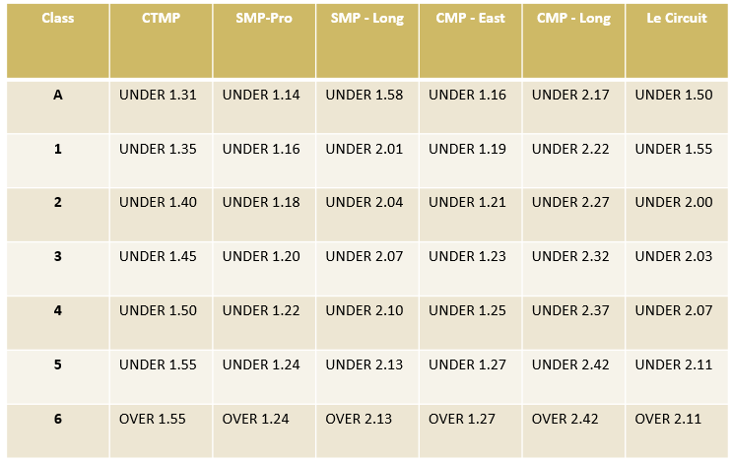

Preliminary VARAC 2019 event schedule

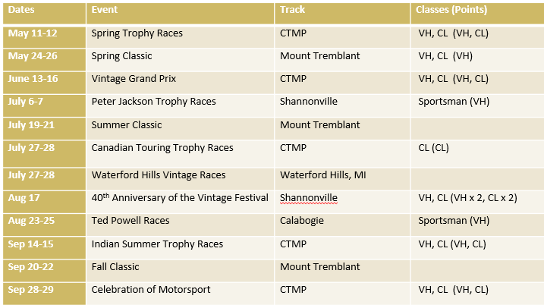

M/S/C = moved/seconded/carried.
M/S/C = moved/seconded/carried.
M/S/C = moved/seconded/carried.
M/S/C = moved/seconded/carried.
M/S/C = moved/seconded/carried.
M/S/C = moved/seconded/carried.
M/S/C = moved/seconded/carried.

